Project Charter Template Guidelines for Use

Document Change Control

VERSION | DATE | AUTHOR(S) | BRIEF DESCRIPTION
1.0 | 08.16.13 | PMO Advisory Council Charter Team: Jim Borron, Aimee Hague, Tedford Armistead, Patricia Buickerood | Basic Charter Template Instructions
1.2 | 09.16..13 | PMO Advisory Council Charter Team: Jim Borron, Aimee Hague, Tedford Armistead, Patricia Buickerood | Minor formatting adjustments. Changed version number to match current version of templates.
1.3 | 12.20.13 | Margaret Ronald | Minor formatting adjustments.

Size Guidelines
The project charter is a commitment document that describes the work that you will do for the requestor. The level of detail and complexity of the charter should be consistent with the size and complexity of the project.
Below you will find the guidelines for sizing HUIT projects. Please keep in mind that these are guidelines to use as a rule of thumb. Common sense and experience should inform the determination of the size of a project.
Size | Scope | Est. Duration | Budget (direct costs)
Small | Simple | 2 to 4 Weeks | $0 – $50,000
Medium | Moderate | 1 – 3 Months | $50,001 - $500,000
Large | Complex | 3 – 12 Months | 500,001 - $1,000,000
V Large. | V Complex | 1 or more Years | More than $1,000,000

Exceptions
In cases of exceptions, the project manager should work with their service area representative on the PMO Advisory Council to ensure that the project size is appropriate for the level of management and control necessary to avoid undue risk.
For example, a project to purchase and install a small application on a server might be small in terms of scope and duration, but the cost could exceed $50,000 because of software licensing charges. This would be characterized as a small project. A project with an estimated duration of 4 months because of the availability of developers or dependencies on another project may still be small, because it requires very little work.

Capital IT Funded Projects
Projects funded through the Information Technology Capital Review Board (ITCRB) must complete the templates required by the Capital IT Funding process. These templates include all the content described in the Charter.

Template Guidelines by Project Size
Size Chart
Charter Element | Small | Medium | Large/ Very Large
Email or memo format
Word Template
Executive Overview
Background
Problem Statement
Vision/Approach
Business Value
ROI
Deliverables/Work Products
Success Criteria
Strategic Alignment
Pyramid Category
Architecture
Scope
Stakeholders
Communication Plan
Roles and Responsibilities
Schedule
Timeline
Milestones
Cost
Constraints
Assumptions
Dependencies
Risks

Small Project “Charter”
The small project charter may be in the form of an email or a memo. It is not necessary to use the Word template.
- Schedule
  - If the start and end dates are known then use those.
  - If the project start date has not been confirmed use durations instead of dates: “UAT will be three weeks from start of project”
“GoLive will be one week after the completion of UAT”
- Cost (if available)

Medium
The medium, large and very large projects should use the MS Word templates.

Large
Large charters should incorporate all the elements of a medium project and the additional elements below. These additional elements are included in the template.
  - Executive Overview
  - Background
  - Business Value
    - ROI
  - Strategic Alignment (greenregulatoryarchitecture)
  - Spending Category Pyramid - (Maintenance/Operations, Enhanced Capabilities, New Capabilities)
  - Architectural Direction
  - Communication Plan
  - Roles & Responsibilities (customer involvement)

Other Resources
There are a number of resources available to help you understand why and how project charters are used and effective change management and communication techniques. One of these is the Harvard Manage Mentor, which is available to Harvard Employees at no cost.
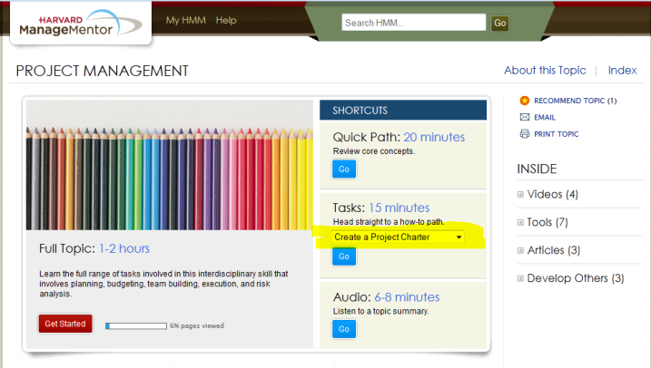
Hundreds of management topics are covered in this resource. Two particularly worthwhile topics are Project Management, which includes a section on how to write a project charter, and Change Management, which discusses the need for and techniques to communicate the changes your project aims to achieve.
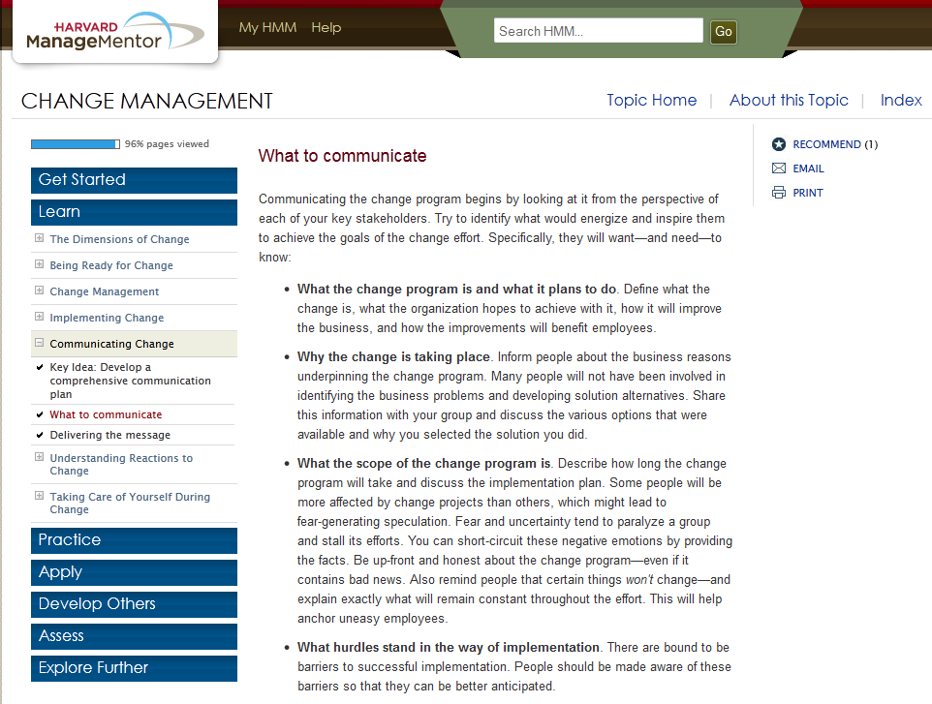

Sections

Executive Overview
This section is a brief overview to provide a concise description of the problem, the affected people and organizations, the impact, a description of the proposed solution, the schedule, and costs. The audience for the Executive Overview is a member of the senior leadership team. The Executive Overview should provide the reader with a quick summary of the project and should not be more than one page long. The details will be provided in later sections.

Problem Statement
“A problem well defined is half solved.” Henry Road
A problem statement should be concise, written in laymen’s terms and include the following:
- A brief description of the problem and the metric used to describe the problem
- Where the problem is occurring by process name and location
- Who is affected by the problem (number of people, names of departments, schools, centers, etc.)
- The time frame over which the problem has been occurring
- The size or magnitude of the problem
- If possible, cost metrics

Vision/Approach

Describe the solution.

Vision
The vision should describe the desired future state.
A vision is a description of the desired state or ultimate condition that should exist after the project has been completed. It is typically expressed in a brief summary of what the stakeholders expect this effort to achieve. A good vision will describe the future state and should provide relevant background. A clear, well-articulated vision with convincing project outcomes can have a strong and positive impact on project success. It helps focus both the stakeholders and the project team and is especially useful when designing solutions.
A classic way to validate the project vision statement is the 30 second test: “Can you explain your project to a stranger in thirty seconds?”
Vision Example: An ideal solution would automatically generate accurate, up-to-date equipment reports once a month and also allow any user to generate reports on demand.

Approach
The approach should describe (as briefly and succinctly as possible) how the project will arrive at the future state. If the project will be delivering functionality in phases or iterations, this section should explain that. If the project is following a particular methodology or SDLC, it should be noted here.

Business Value
What value will this project deliver to the business? This could be cost reduction or income improvement but is much more likely to address duration, effort, volume or quality. Will this project reduce the number of people involved in doing a task? Will it reduce the number of errors or allow more work to be done in a timeframe? Some examples:
- Increase the number of invoices processes in one day from 300 to 900.
- Reduce the error rate on student registration from 18% to 5%
- Reduce the time to get new employees into the HR system from 3 days to 2 hours.
- Increase capital campaign contributions by 1%
- Reduce time to complete month-end closing from five business days to two

ROI

Return on Investment is a very specific finance term. Work with the HUIT PMO, the VP of the group or the CIO of the school to develop this value.

Deliverables/Work Products
What functions or work products will be delivered to the users? What will the user be able to do differently when this project is completed or what new capability will be delivered? Some examples are:
- Ability to create/update delete new students
- Create, update and delete links between lectures and labs
- Online training modules for each new function

Success Criteria
How will the project and the customers measure whether or not the goals have been met? If the project defined a business value, then you should be able to identify a metric to measure whether you have delivered that value. Some examples are:
- By the third month-end close using the new system, the Finance Team should be able to complete the closing process in two business days without adding any additional staff. This will be measured by the Finance Manager, who will mark the beginning and end date and time for closing.
- By 60 days on the new system, the average volume of invoices processed by a single AP clerk should increase to 300 per day. This will be measured by daily reports produced by the system.

Define how to measure “done.”
Most project managers consider the work done when the project team has delivered all the agreed work products, addressed all the significant defects and placed the work into production. However, most users or customers regard the work as done when they are successfully using the product or software and are meeting their goals. The Project Manager should discuss “done” with the sponsor and agree on a clear definition of complete. During that discussion you should consider whether a period of intense support is needed when the work first goes into production. Quality should also be addressed. Is the work “done” after all the critical and high defects have been closed or is it necessary for all defects to be closed?

Scope

Out-of-Scope
If it is likely that there will be some confusion about scope use this section to explicitly detail what is NOT in scope. For example:
- Graduate School of Education, Harvard Business School and Harvard Medical School are not in scope for this project.
- 1414 Massachusetts Avenue HUIT locations are not in scope.

Stakeholders/People

Who is the work being done for? (Sponsor)
If there are multiple sponsors, identify the primary sponsor and co-sponsors.

Who is funding the work?
Who (what department or fund) is paying for this work? How is this work being funded? Some examples are Fee-for-Service, ITCRB Capital IT Funding, HILT funds, Operations Budget, etc…

What organizations or departments or people will benefit from this work?

Who will accept the work?
In many cases, the sponsor is a senior executive who will not be involved in the day to day project details or in user acceptance testing. In these cases, the sponsor should delegate acceptance to someone who can be involved enough to approve and accept the work. Provide the name and title of the person or persons who will accept the work.

Who is the Project Manager?
There should be one primary project manager. In some cases, there is a project manager from the business or school area as well as someone from HUIT. In such cases, the project manager is the person who is managing the work. In other cases, the project is divided into sub-projects with each department appointing a project manager. In this situation, the person who the sponsor holds accountable for getting the work done is the project manager. The departmental project managers are team leaders.

What organization or service area is performing the work?
In many cases there are multiple HUIT service areas involved in the project. This section should list the organization that is primarily responsible to the sponsor for getting the job done and then list all the other involved groups.

Schedule and Cost

Schedule
At a minimum this section should list planned start dates, user acceptance testing start and end dates, training start and end date, and the planned date for move into production.
Medium, large, and very large projects should show planned start and end dates for phases and user relevant activities such as requirements development and user acceptance testing.
Projects being conducted using Scrum should indicate planned start and end dates and the duration of the sprints.

Cost
The project templates contain an embedded spreadsheet with a list of some common project costs. Complete this spreadsheet as necessary. You may remove cost types that are not pertinent and add any costs that are not on the sheet.
To use the spreadsheet just double-click in the chart.

Other

Constraints
Constraints are limitations that influence or control how the project is organized, the costs, or timeline of the project. Cost is a typical constraint. The sponsor is willing to fund a project to a certain level and no higher. Resource availability is a very common constraint because project schedules are absolutely dependent on resource schedules. Another constraint is time. An example is a project that absolutely must be completed before new legislation is enacted.

Assumptions
If the project assumes that users will be available to develop requirements, test, and train during certain periods, then it would be worthwhile to note that assumption. Another example is a project that assumes the availability of a web development platform.

Dependencies
Frequently projects are dependent on some condition being true or some other work being completed. For example, the development of new reports in a business intelligence data warehouse is dependent on the project to build the data warehouse completing on time. A project to implement new vendor software may have a dependency on the vendor upgrade release schedule.
In some cases, other projects are dependent on the completion of this project. For example, one project may be building an enterprise identity management application. A different project to build a new, secured web application could not complete until this project delivers the identity management solution.

Risks
Developing a list of project risks involves gathering information from many sources. The project manager and project team bring their experience from other projects. Project team and stakeholder brainstorming can identify additional risks. Many project managers use risk checklists to help them identify project risks. Risks from previous projects, common risk categories and discussions with sponsors and other project managers should help the project manager arrive at a list of risks.
Each risk should be described using an If, then clause. Action may be Avoid, Accept, Transfer, Mitigate.
Risk Description | Action | Owner | Response Plan | Timing of Impact
If a major weather event (blizzard, hurricane, flooding), labor strike, or terrorism disrupts travel, then the project will incur additional costs and added time to completion. | Accept | Joe, Project Manager | Add contingency to the project budget to be used for travel and expenses for consultants in the event of a travel disruption. | Unknown
If the selected software does not prove out through the proof of concept then it will be necessary to change to the second choice vendor. This will cause significant delays and rework, thus adding to costs and schedule. | Mitigate | Alice, Technical Lead | Begin testing software as soon as possible and keep close track of defects. Review daily testing metrics. | Week four of project
If the lead consultant on the vendor team leaves the vendor (changes jobs) then the project costs will increase and there may be delays due to hiring cycle and learning curve. | Transfer | Joe, Project Manager | Ensure that the contract with the consulting firm holds them accountable if key staff leave. Include provisions to have the vendor pay 1st four weeks of labor and expense for replacement consultant. | Unknown

